KidzCoding Hour of Code - Reaction Time Game

Activity:

In this activity, students will make a **simple game** that measures the player’s reaction time. This activity will utilize **events, variables,** and some **mathematics.** This game will measure reaction time by changing the screen color to green at a random time and measure the time it took the player to click the screen.

Learning Objectives:

* Learn how to use events to create interactive games
* Understand how variables can be used to store important information
* Utilize math and randomness

Materials:

* Completed Game - <https://scratch.mit.edu/projects/875958078/editor>
* Starter Project - <https://scratch.mit.edu/projects/875962622/>

Coding Time!

Variables

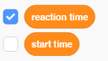

This game will use two variables. Reaction time is the variable that we will use to keep track of the player’s reaction time. Start time is a variable that we will use to calculate the player’s reaction time. (You will see how this is done later in the lesson)

The Backgrounds

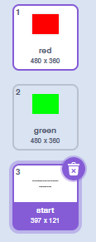

This game will use three different backgrounds. The white background is the starting screen and it will give the player the directions to play the game. The red background is the start of the actual game. The green background lets the player know when to click the screen to measure reaction time.

**Coding the Game**

**1. Setting the Background**

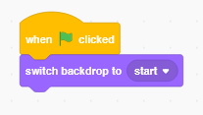

When the player runs the game, we need to set the background to the starting screen so that the player knows what to do.

**2. Starting the Test**

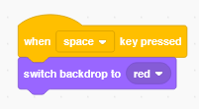

The game will actually start when the player presses space. We want to set the background to red so that the player knows not to click yet.

**3. Changing the Background**

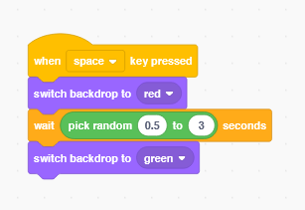

To measure reaction time, we are changing the color of the background to green and then timing the player on how long it takes to click the screen. We need to wait a random amount of time before switching it to green so that the player isn’t able to guess when the background will switch.

**4. Starting the Timer**

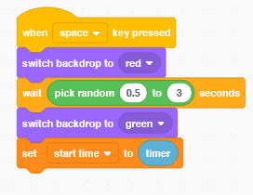

The blue timer block is the time that it is now. We need to store this time in the variable start time so that we can figure out how long it takes the user to click.

**5. Ending the Test**

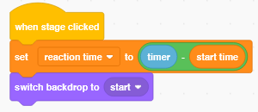

We will use the event of the player clicking the screen to end the test. When the player clicks the screen, we need to find how much time has gone by since the test started. To do this, we subtract the starting time from the time that it is now (current time - start time). This will tell us how much time has passed since the screen turned green, which is the reaction time of the player.

Congratulations, you have just completed an Hour of Code!

Bonus Challenge:

Use a list to keep track of the best times that the player does.